GoToMeeting hearing and vision impairment accessibility-

High Contrast Mode
High contrast mode helps users with vision impairment or compromised vision. Learn how to enable high contrast mode on Windows. The following screens support each of the Windows high contrast modes:
- Out of session windows (e.g., Select audio mode, Preferences, Scheduler, My Meetings)
- In-session images, text, links, and windows (e.g., Control Panel, Viewer, Report Audio Issues, tooltips)
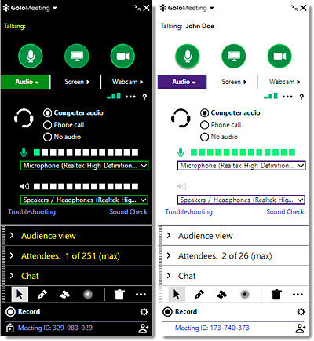

Font Size & Color Scheme
Color contrasts and font size help with visual communication and improve information access for users with vision impairment or compromised vision. The following screens have passed the color and font standards:
- Out of session windows (e.g., Select audio mode, Preferences, Scheduler, My Meetings)
- In-session images, text, links, and windows (e.g., Control Panel, Viewer, Supporting Dialogs)

Tab Navigation
Tab navigation allows users to maneuver through elements on and in the software from the keyboard alone using the Tab key. This helps users who are unable to use a mouse. You can navigate through the following screens using the Tab key.
- Out of session windows (e.g., Select audio mode, Preferences, Scheduler, My Meetings)
- All in-session windows and Control Panel (e.g., Chat pane, Leave session)
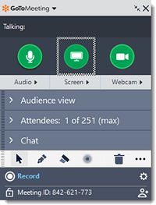

Keyboard Shortcut
Keyboard shortcuts allow users to trigger and take action with a combination of keys rather than a mouse. This helps users who are unable to use a mouse. Learn more on which keyboard shortcuts we support while in a session.

